To check if IMC is receiving SNMP Traps from a device, navigate to Alarm > Trap Management > Browse Trap:
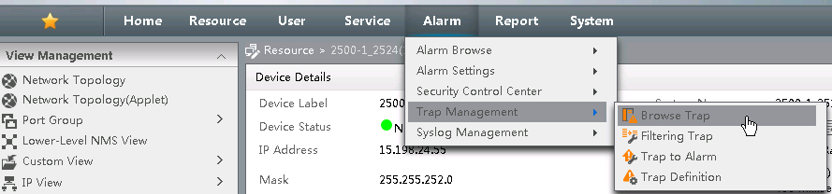

Add the IP Address of the 10500 or 5500 device to view just the traps received by that device:

If the switch has been configured to send SNMP Traps to IMC, we should see the Trap Description.
Select the Description Field to view the SNMP OID associated with the SNMP Trap:
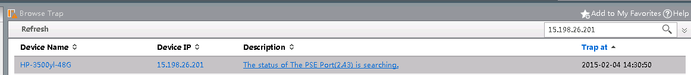

If the trap has been sent to IMC, we should receive the Trap Details:
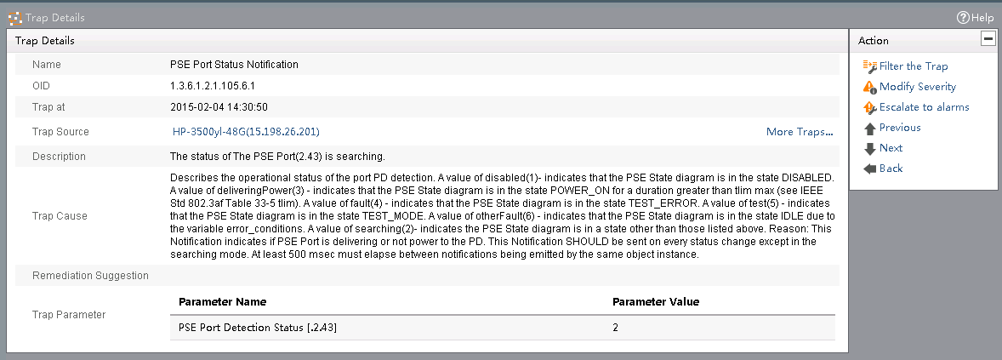
If the trap is seen, but does not trigger an Alarm under Alarm > Alarm Browse > All Alarms, use the “Escalate to Alarms” option under the Action menu on the right-hand side.
If the trap is not showing in the Browse Trap, then the configuration of the switch should be checked to ensure the IMC server has been registered as an SNMP Trap Host.
If the trap is showing as an Unknown Trap, then the trap would be filtered as Unknown by default. The SNMP MIBs for the trap would need to be loaded into IMC. This process can be found in the IMC Administrators Guide.
Link to IMC Manuals:
http://h20565.www2.hp.com/portal/site/hpsc/template.PAGE/public/psi/manualsResults/?sp4ts.oid=4176535&spf_p.tpst=psiContentResults&spf_p.prp_psiContentResults=wsrp-navigationalState%3Daction%253Dmanualslist%257Cviewall%253Dtrue%257Clang%253Den&javax.portlet.begCacheTok=com.vignette.cachetoken&javax.portlet.endCacheTok=com.vignette.cachetoken

